Social Links

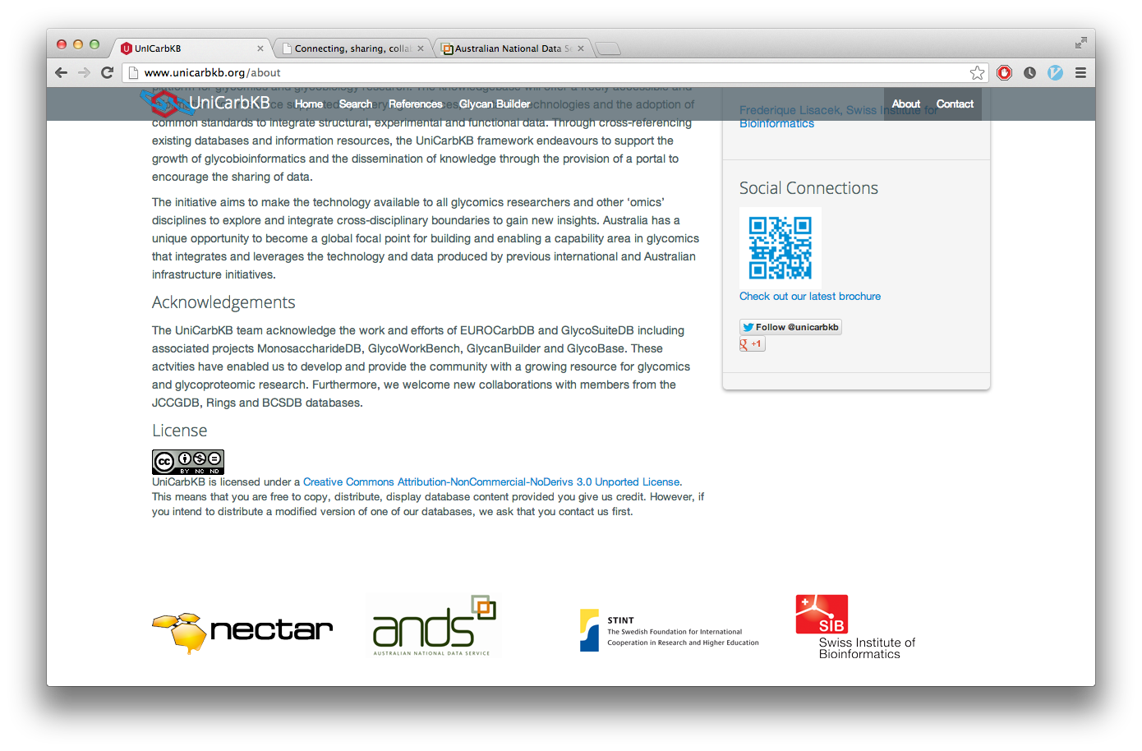
- Social links should endeavor to appear only once per page to avoid redundancy and visual clutter
- When appearing as a block, social links should either be positioned at the bottom of the page (in the footer, aligned to the right), or at the bottom of the left-hand information box (usually found on blogs and the like). Links should be arrayed evenly to avoid visual noise.
- When provided individually, social links should appear to the right of a given link or story to indicate their attachment to the given piece of information
- RSS links should be provided in a separate page (if comprehensive), or in the banner of a website system if individual
- Twitter links, i.e. 'Tweet This' or 'Follow Me' should appear at the bottom of articles or news stories (if applicable)

